
Intro to Microsoft OneNote

Microsoft OneNote is a powerful digital notebook designed to help you capture ideas, organize information, and collaborate seamlessly. According to Microsoft, OneNote allows you to “gather your notes, plans, and information in one place—across devices—with flexibility and creative freedom.” While OneNote has been around for years, its capabilities have expanded significantly. From structured notebooks to searchable tags, embedded files, handwriting tools, and real-time collaboration, OneNote has become an essential productivity app.

During this course, you will watch a live demonstration of introductory OneNote functions and tools to help you build organized, easy-to-navigate notebooks. You will then have lab time to practice these functions while the instructor is available to guide and answer questions.

The learning objectives for our course are:
- Understand how OneNote notebooks are structured and what they are commonly used for.
- Create and organize notebooks, sections, and pages for clarity and efficiency.
- Insert and format content such as text, images, files, tables, and tags.
- Use OneNote tools—including templates, drawing tools, and search—to enhance productivity.
- Collaborate and share notebooks with others using permissions and syncing features.
Microsoft OneNote Overview

What is OneNote typically used for?
____________________________________________________________________________________________________________________________________

Common OneNote verbiage:

- Notebooks_______________________________________________________
- Sections_________________________________________________________
- Pages___________________________________________________________
- Tags____________________________________________________________
- Syncing_________________________________________________________

Differences between desktop, web and mobile:
____________________________________________________________________________________________________________________________________

Notebooks, Sections, and Pages: The Core Structure:
____________________________________________________________________________________________________________________________________

Additional Notes:

____________________________________________________________________________________________________________________________________
__________________________________________________________________

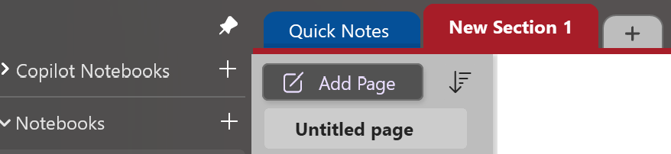
Microsoft OneNote
Creating & Organizing
Notebooks

Starting a New Notebook:
____________________________________________________________________________________________________________________________________

Creating Sections and Pages:
____________________________________________________________________________________________________________________________________

Renaming, Moving, and Deleting:
____________________________________________________________________________________________________________________________________

Color Coding and Organizing for Clarity:
____________________________________________________________________________________________________________________________________

Additional Notes:
__________________________________________________________________
____________________________________________________________________________________________________________________________________
__________________________________________________________________

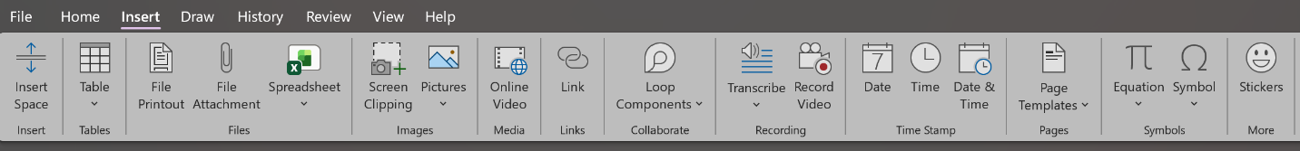

Microsoft OneNote Content Creation

Adding Text, Titles, and Lists:
____________________________________________________________________________________________________________________________________

Inserting Images, Files and Links:
____________________________________________________________________________________________________________________________________

Using Tables and Tags:
____________________________________________________________________________________________________________________________________

Audio Recording and Handwriting Input:
____________________________________________________________________________________________________________________________________

Additional Notes:
__________________________________________________________________
____________________________________________________________________________________________________________________________________
__________________________________________________________________

Microsoft OneNote Lab and Q & A
Content Creation

Exercises:

- Create a new notebook titled Training Notebook.

- Add at least three sections: Overview, Notes, and Resources.

- Add two pages inside the Overview section.

- Insert a bulleted list on the first page.

- Add an image to the second page using Insert > Pictures.

- Insert a file attachment into the Resources section.

- Add at least two tags (e.g., To Do, Important).

- Try handwriting or drawing tools if available on your device.
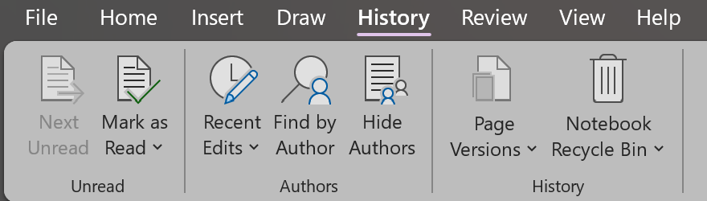
Microsoft OneNote
Collaboration & Sharing
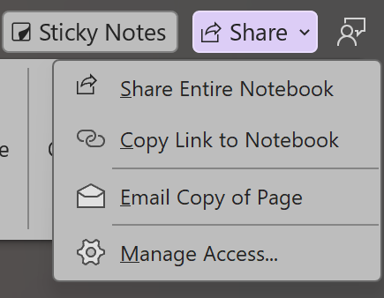

Sharing Notebooks with Others:
________________________________________
________________________________________
________________________________________
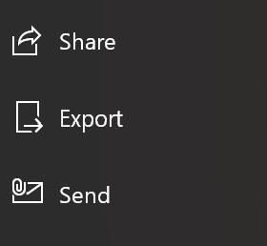
________________________________________

Permissions and Syncing:
________________________________________
________________________________________
____________________________________________________________________________________________________________________________________

Real-Time Collaboration Tips:
____________________________________________________________________________________________________________________________________

Additional Notes:
__________________________________________________________________
____________________________________________________________________________________________________________________________________
__________________________________________________________________

Formatting & Customization

Page Templates and Backgrounds:
____________________________________________________________________________________________________________________________________

Using Drawing Tools and Stylus Features:
____________________________________________________________________________________________________________________________________

Custom Tags and Search Functions:
____________________________________________________________________________________________________________________________________

Additional Notes:

_____________________________________________________________________________

_____________________________________________________________________________

_____________________________________________________________________________

_____________________________________________________________________________

__________________________________________________________________

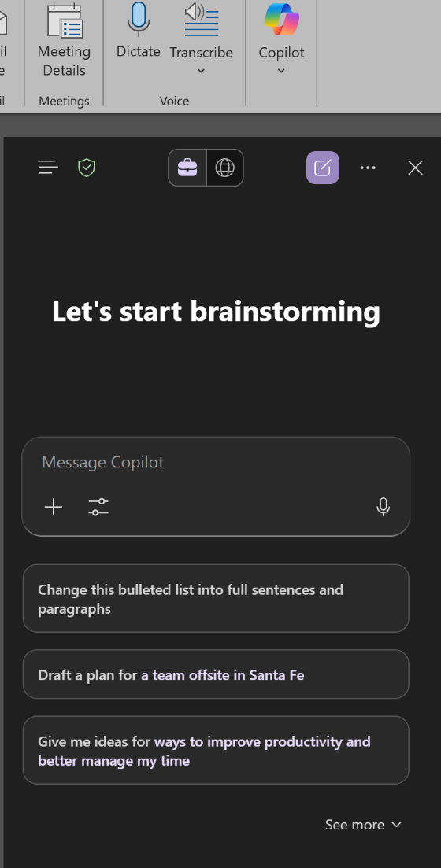
Integration & Productivity Features

Outlook and Teams Integration:
________________________________________
________________________________________
________________________________________
________________________________________

Task Management and To-Do Lists:
________________________________________
________________________________________
________________________________________
________________________________________

Using OneNote with Copilot or other AI Tools:
________________________________________
________________________________________
____________________________________________________________________________________________________________________________________

Additional Notes:

_____________________________________________________________________________

_____________________________________________________________________________

_____________________________________________________________________________

_____________________________________________________________________________

Microsoft OneNote Lab and Q & A
Formatting & Productivity

Exercises (Continue in your OneNote Lab Exercise document):

- Apply a page template to one of your pages.

- Create a to-do list using checkboxes.

- Add a meeting note using Outlook integration (if available).

- Use the search bar to find a tag or keyword.

- Reorganize your sections by dragging them into a new order.

- Experiment with drawing tools—add a handwritten note or highlight text.

- Explore the Share options in the upper right corner.

3 - 5 Takeaways:

1 - 2 Action Steps:

