Policies only work if they’re practiced consistently. But managers interpret, employees test boundaries, and HR gets stuck in the middle. AI can help bridge the gap, spotting inconsistencies, simplifying communication, and coaching managers without adding more to your plate.
Practical AI Use Cases
- Policy Summarizer:
  - Upload your handbook or policy doc.
  - Generate plain-English FAQs for managers (“What’s the dress code?” → “Business casual, jeans on Fridays.”)
- Consistency Checker:
  - Compare a manager’s email or note against official policy.
  - AI highlights where the message drifts off course.
- Scenario Coaching:
  - Ask AI: “How would an employee challenge our PTO policy?”
  - Practice your responses with consistent, policy-aligned phrasing.
Cautions & Guardrails
- No Legal Shortcuts: AI = tool, not legal advice. Always review.
- Protect Confidentiality: Never upload PII or sensitive employee data.
- Human in the Loop: AI drafts, HR decides what gets shared.
Try It in Your Org __________________________________________________________________
Challenge Prompt: Pick one HR pain point where managers are inconsistent. Ask AI to:
- Summarize your policy in plain language.
- Draft a sample communication to employees.
- Highlight where inconsistency might creep in.
Remember: AI doesn’t replace HR, it empowers you. Use it to coach, align, and create the clarity employees trust.
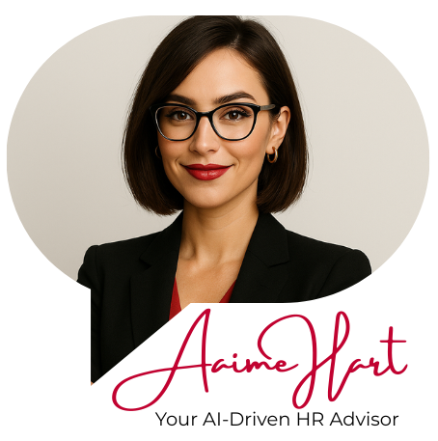
Built by seasoned HR pros who’ve led tough conversations, written policies under pressure, and answered the “got-a-minute” questions for years, Aaime Hart gives you fast, compliant, real-world guidance – no Googling required.
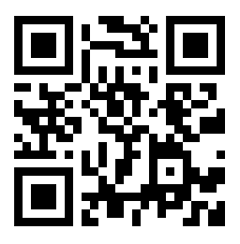
scan the qr code to get started

Ask her what you’d ask a trusted HR pro
She’s built to help with both the big-picture strategy and the messy day-to-day moments.
