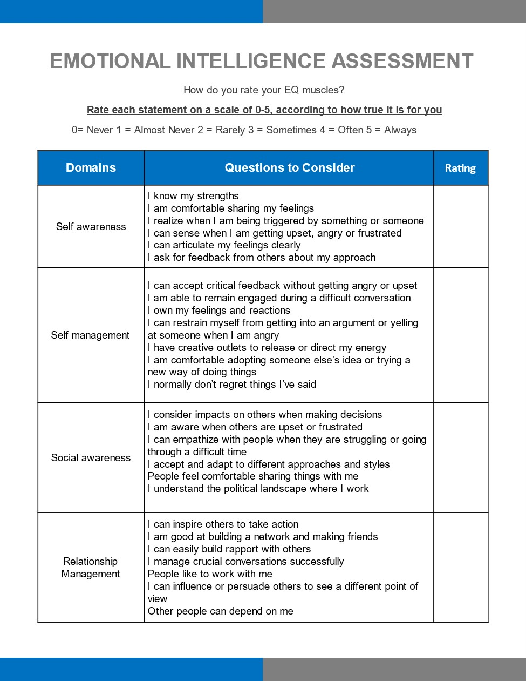

EMPATHY
- What impact do you think your emotional expression (or lack of expression) has on others?
- What can you do differently in the future to show more empathy in your HR role?
